DATABASE MANAGEMENT SYSTEMS
UNIT-1

INTRODUCTION:
Database: The collections of related data are called as database.
Database management system: It is a collection of interrelated data and a set of programs to access those data.
FILE PROCESSING SYSTEM: It is supported by a conventional operating system. The system stores permanent records in various files. It’s having some disadvantages,
1. Data redundancy and inconsistency
2. Difficulty in accessing data
3. Data isolation
4. Integrity problems
5. Atomicity problems
6. Concurrent access anomalies
7. Security problems

S no | Database | File system
1 | Data are not redundant and consistent | Data are redundant and inconsistent
2 | Easy to access | Difficult to access
3 | It ensures integrity, atomicity and security | It doesn’t ensures it
4 | Data can be concurrently accessed | Concurrent access is not possible
5 | Easy to retrieve appropriate data | Difficult to retrieve appropriate data
DATABASE SYSTEM VS FILE SYSTEM:

APPLICATIONS OF DATABASE MANAGEMENT SYSTEMS:

Railway Reservation System
Database is required to keep record of ticket booking, train’s departure and arrival status. Also if trains get late then people get to know it through database update.

Library Management System
There are thousands of books in the library so it is very difficult to keep record of all the books in a copy or register. So DBMS used to maintain all the information relate to book issue dates, name of the book, author and availability of the book.

Banking
We make thousands of transactions through banks daily and we can do this without going to the bank. So how banking has become so easy that by sitting at home we can send or get money through banks. That is all possible just because of DBMS that manages all the bank transactions.

Universities and colleges
Examinations are done online today and universities and colleges maintain all these records through DBMS. Student’s registrations details, results, courses and grades all the information is stored in database.

Social Media Sites
We all are on social media websites to share our views and connect with our friends. Daily millions of users signed up for these social media accounts like face book, twitter, interest and Google plus. But how all the information of users are stored and how we become able to connect to other people, yes this all because DBMS.

Telecommunications
Any telecommunication company cannot even think about their business without DBMS. DBMS is must for these companies to store the call details and monthly post paid bills.

Finance
Those days have gone far when information related to money was stored in registers and files. Today the time has totally changed because there are lots f thing to do with finance like storing sales, holding information and finance statement management etc.

Military
Military keeps records of millions of soldiers and it has millions of files that should be keep secured and safe. As DBMS provides a big security assurance to the military information so it is widely used in militaries. One can easily search for all the information about anyone within seconds with the help of DBMS.
Disadvantages of file management systems:

- Data Mapping and Access: - Although all the related information’s are grouped and stored in different files in same directory, there is no mapping between any two files.
- Data Redundancy: - There are no methods to validate the insertion of duplicate data in file system. Decentralization of data leads to data redundancy.
- Data Dependence: - It is to store the data in flat files. So there is no dependent on files.
- Data inconsistency: - It is due to decentralization of data[i.e. no updating of the data ]
- Data Isolation: separation of data [individuality]
- Security: - Each file can be password protected. But what if have to give access to only few records in the file? For example, user has to be given access to view only their bank account information in the file. This is very difficult in the file system.
- Integrity: In FMS it does not check the rules.
- Atomicity: - It depends on transaction which means set of actions. Transaction is done or undone is atomicity.
- Concurrent Access: - In FMS, multiple users cannot access same file at same time.

NOTE: All these disadvantages in reverse become the advantages of Database management systems.
Schema:
The overall design of the database is called database schema. Schema will not be changed frequently. It is the logical structure of a database. It does not show the data in the database.
Types of Schemas:
Physical schema
Logical schema
External
Instance
Instance or extension or database state is a collection of information that stored in a database at a particular moment is called an instance of the database. The Database instance refers to the information stored in the database at a given point of time. Thus, it is a dynamic value which keeps on changing.

VIEW OF DATA: The database system provides an abstract view of data to users. The system hides details of how the data is stored and maintained. Here we are including 2 things,

1. Data abstraction: Data is hidden through various levels of abstraction such as,

a. Physical level
b. Logical level
c. View level
a) Physical level- The lowest level of abstraction describes how the data are physically stored. The physical level describes complex low level data structure.

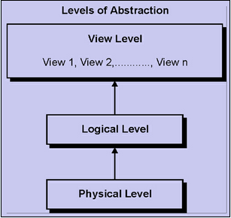

b) Logical level- The next level of abstraction describes about data is stored in the database, and what relationship exists among those data. It describes the entire database in terms of a small number of relatively simple structures.
c) View level- The highest level of abstraction describes only part of the entire database. The view level of abstraction exists to simplify their interaction with the system. The system may provide many views for the same database.

2. Instances and schema: The collection of information stored in the database at a particular moment is called an instance of the database. The overall design of the database is called the database schema. Types of schemas are
1. Physical schema- describes the database design at the physical level.
2. Logical schema-describes the data database design at the logical level.
3. Sub level- describes the data database design at the view level.

Data Independence:
A database system normally contains a lot of data in addition to users’ data. For example, it stores data about data, known as metadata, to locate and retrieve data easily. It is rather difficult to modify or update a set of metadata once it is stored in the database. But as a DBMS expands, it needs to change over time to satisfy the requirements of the users. If the entire data is dependent, it would become a tedious and highly complex job.
Metadata itself follows a layered architecture, so that when we change data at one layer, it does not affect the data at another level. This data is independent but mapped to each other.

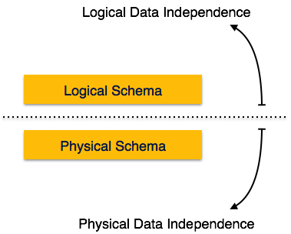

Logical Data Independence
Logical data is data about database, that is, it stores information about how data is managed inside. For example, a table (relation) stored in the database and all its constraints, applied on that relation.
Logical data independence is a kind of mechanism, which liberalizes itself from actual data stored on the disk. If we do some changes on table format, it should not change the data residing on the disk.

Physical Data Independence
All the schemas are logical, and the actual data is stored in bit format on the disk. Physical data independence is the power to change the physical data without impacting the schema or logical data.
For example, in case we want to change or upgrade the storage system itself − suppose we want to replace hard-disks with SSD − it should not have any impact on the logical data or schemas.

DATA MODELS: A data model is a collection of concepts that can be used to describe the structure of a database.
It provides the necessary means to achieve the abstraction.
By structure of a database we mean the data types, relationships and constraints that apply to data.
Design of database is called data model
Data models are classified into three types:
1. Object based model
1. Object oriented model
2. E-R model
3. Functional model
2. Record based model
1. Relational model
2. Network model
3. Hierarchical model
3. Physical model
1. Unify model
2. Frame model

Object oriented model:
This data model is another method of representing real world objects. It considers each object in the world as objects and isolates it from each other. It groups its related functionalities together and allows inheriting its functionality to other related sub-groups.
E-R model:
In the below diagram, Entities or real world objects are represented in a rectangular box. Their attributes are represented in ovals. Primary keys of entities are underlined. All the entities are mapped using diamonds. This is one of the methods of representing ER model. There are many different forms of representation. Basically, ER model is a graphical representation of real world objects with their attributes and relationship. It makes the system easily understandable. This model is considered as a top down approach of designing a requirement.
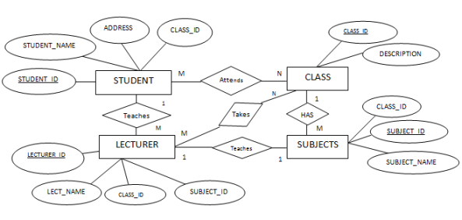

Functional model:
In functional model the data is stored and accessed in form of functions.
Hierarchical model:
In this data model, the entities are represented in a hierarchical fashion. Here we identify a parent entity, and its child entity. Again we drill down to identify next level of child entity and so on. This model can be imagined as folders inside a folder.
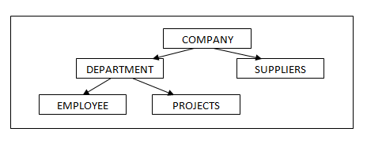
Network model:
This is the enhanced version of hierarchical data model. It is designed to address the drawbacks of the hierarchical model. It helps to address M:N relationship. This data model is also represented as hierarchical, but this model will not have single parent concept. Any child in the tree can have multiple parents here.

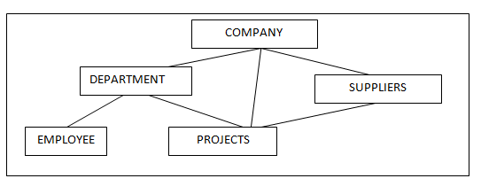
Relational model:
This model is designed to overcome the drawbacks of hierarchical and network models. It is designed completely different from those two models. Those models define how they are structured in the database physically and how they are inter-related. But in the relational model, we are least bothered about how they are structured. It purely based on how the records in each table are related. It purely isolates physical structure from the logical structure. Logical structure is defines records are grouped and distributed.
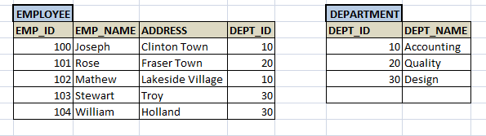

Physical model:
Physical data model represent the model where it describes how data are stored in computer memory, how they are scattered and ordered in the memory, and how they would be retrieved from memory. Basically physical data model represents the data at data layer or internal layer. It represents each table, their columns and specifications, constraints like primary key, foreign key etc. It basically represents how each tables are built and related to each other in DB.
In short we can say a physical data model has
- Tables and its specifications – table names and their columns. Columns are represented along with their data types and size. In addition primary key of each table is shown at the top of the column list.
- Foreign keys are used to represent the relationship between the tables. Mapping between the tables are represented using arrows between them.
- Physical data model can have denormalized structure based on the user requirement. The tables might not be in normalized forms.
DATA BASE ACCESS FOR APPLICATION PROGRAMS:
- Data base will not interact directly it will use the software. It is called the embedded software
- The software used is sql.
- This gives the commands to the front end people(navy users)
- The people who interact directly with data base they are known as data base administrators .They have all rights on data base
- The sql statements are combined with the host users ie: front end is called “ embedded sql”
Data base users:
1. Application programmers: Through application statements interacts with DML statements.
- Embedded to host language
2. Sophisticated users: Through direct SQLstatements.
3. Specialize users: Similar to sophisticated users but they write special data base programs like by PL/SQL.
4. Naive users or unsophisticated: Interact with standalone permanent application programs
5. Data base administrators:

DBA can check both technical and non-technical details of the data base.
TRANSACTION MANAGEMENT:
If the transaction is not done properly data will lose the consistency
- Eg: Booking the ticket
- The sequence of operation in an atomic in nature is called a transaction.
- Once the transaction is completed the reflection on data should be done immediately if it is not done consistency will lose.
- Each transaction should follow the ACID properties
A-Atomicity
C-Consistency
I-Isolation
D-Durability
- Atomicity − this property states that a transaction must be treated as an atomic unit, that is, either all of its operations are executed or none. There must be no state in a database where a transaction is left partially completed. States should be defined either before the execution of the transaction or after the execution/abortion/failure of the transaction.
- Consistency − the database must remain in a consistent state after any transaction. No transaction should have any adverse effect on the data residing in the database. If the database was in a consistent state before the execution of a transaction, it must remain consistent after the execution of the transaction as well.
- Durability − the database should be durable enough to hold all its latest updates even if the system fails or restarts. If a transaction updates a chunk of data in a database and commits, then the database will hold the modified data. If a transaction commits but the system fails before the data could be written on to the disk, then that data will be updated once the system brings back into action.
- Isolation − In a database system where more than one transaction are being executed simultaneously and in parallel, the property of isolation states that all the transactions will be carried out and executed as if it is the only transaction in the system. No transaction will affect the existence of any other transaction.

Every transaction have 5 states:
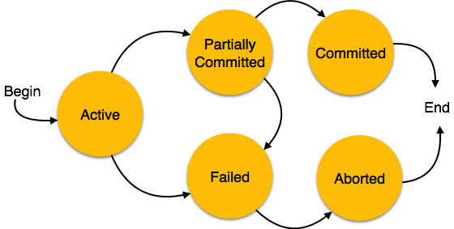

- Active − in this state, the transaction is being executed. This is the initial state of every transaction.
- Partially Committed − When a transaction executes its final operation, it is said to be in a partially committed state.
- Failed − A transaction is said to be in a failed state if any of the checks made by the database recovery system fails. A failed transaction can no longer proceed further.
- Aborted − If any of the checks fails and the transaction has reached a failed state, then the recovery manager rolls back all its write operations on the database to bring the database back to its original state where it was prior to the execution of the transaction. Transactions in this state are called aborted. The database recovery module can select one of the two operations after a transaction aborts −
  - Re-start the transaction
  - Kill the transaction
- Committed − If a transaction executes all its operations successfully, it is said to be committed. All its effects are now permanently established on the database system.

DATA BASE SYSTEM ARCHITECTURE:
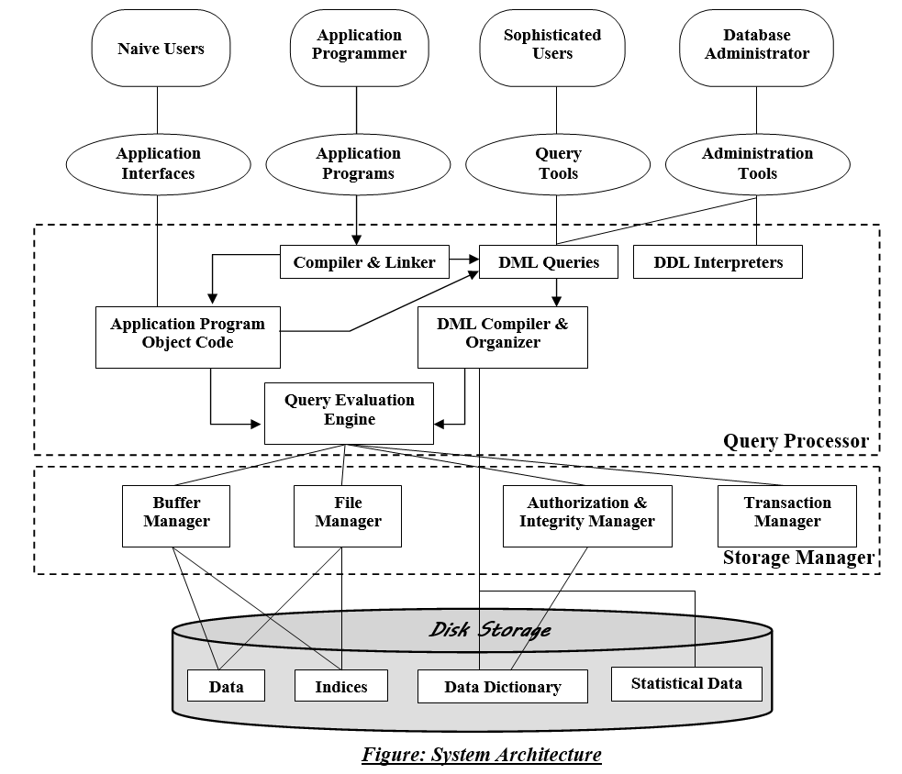
DBMS architecture is mainly divided into 2 modules
1. Query processor
2. Storage manager

1. QUERY PROCESSOR:
The query processor components in dbms accepts sql commands generated from variety of users interfaces ,produce query evaluation plan executes these plans with the data base and return results.
The components are:
DML compiler:
It is which translates DML statements in query language, low level instruction that the query evolution engine understands.
Embedded DML pre-compiler:
Sql commands can be embedded in host language application programs (c, c++, JAVA) which can be converted into DML statements by this embedded DML precompiler. The precompiler interact with the DML compiler to generate appropriate code.
DDL interpreter:
Which interprets the DDL statements and records them in a set of tables containing metadata
Application program object code:
It is which is low level instructions of a program written by no voice users/naive users which the query evaluation engine understands and execute them
Query evaluation engine:
It is which executes low level instructions generated by DML compiler.
2. STORAGE MANAGER:
The storage manager components in dbms provide the interface between the physical level data stored in data base and the program on queries requesting the stored data from data base.
The storage manager components are:
Authorization and integrity manager:
It is which test for the satisfaction of integrity constraints and checks the authority of user to access the data.
Recovery manager:
It is which is responsible for maintaining a log and restoring the system to a consistent state, after system failure.
Transaction manager:
It is which ensure that the data base remains in consistent state despite of the system failure and the concurrent transaction execution proceed without conflicting the transaction.
Lock manager:
A lock is a mechanism used to control access to database objects.
Two kinds of locks are commonly supported by a DBMS: – Shared locks on an object can be held by two different transactions at the same time.
Exclusive lock on an object ensures that no other transaction holds any lock on this object.
Every transaction begins by obtaining a shared lock on each data object that it needs to read and an exclusive lock on each data that it needs to modify, and then release all its locks after completing all actions.
It is which keeps track of requests for locks and grant locks on data in the data base.
Buffer manager:
It is which is responsible for fetching the data from disk storage into main memory and deciding what data to cache memory.
Disk space manager:
It is which manages allocation of space on disk storage and the data structures used to represent the stored information on disk.
Disk storage components are:
Data files:
Which stores the data base itself i.e. The actual data in the data base.
Data dictionary:
It is which stores the Meta data about the structure of data base .The data dictionary is used very heavily. Therefore great emphasis should be placed on developing a good design and efficient implementation of the data dictionary.
Indices:
It is which provides the fast access to the data items that hold the particular value.
Statistical data:
It stores the statistical data about the data in the database .This information is used by the query processor to select efficient ways and to execute user queries.

